Feel Free to Share
Hi all.
I have gotten a few emails where the writer assures me that they have not told anyone about this folder.
I want you to know that that is not how i feel about it. You are free to share the link to this folder with anyone. Correct link: da.getmyip.com/pdf
The files here do not belong to me, they belong to Jehovah, and should be able to benefit any of the brothers and sisters as much as they benefit you. (Mt 10:27)
The more that visit here, and my Ramblings folder, the more of a chance that another JW will have their eyes opened.
So don't be shy about sharing.
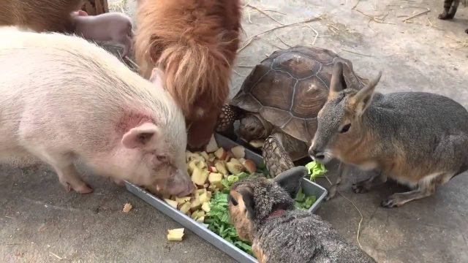

:^)
Dave
da.getmyip@gmail.com http://da.getmyip.com/PDF/Ramblings

Last updated: 04-19-2023 (Date created: 09-15-2019)

